School name and logo

Class name and logo

Name: _______________________________________

Age: _______________________________________

Height: _______________________________________

Weight: _______________________________________

Teacher: _______________________________________

Date: _______________________________________
Baby: 3 months old

Each child is unique. Each child develops at his/her own pace; therefore no 2 children’s milestones will be achieved at exactly the same time.
Please give a 2 - 3 month leeway to either side of the time frame given (e.g. if it says that a child has to walk when he is 1 year old it can mean that the child may start walking when he is 9 months old or 15 months old).
If you see that your child has a delay in more than 2 important areas, please consult your developmental paediatrician.
When a child has a developmental delay it is recommended that the child receives therapy: speech therapy, occupational therapy, play therapy or whichever kind of therapy your paediatrician recommends.
A child that has a developmental delay usually reaches a plato when 12 years old. Thus it is so important that a child receives therapy from as early an age as possible.

V - Very good
F - Functional for age group
N - Needs some help/assistance
P - Problematic

Please note: The term he / she is used interchangeable in this report but indicates both sexes.

Movement
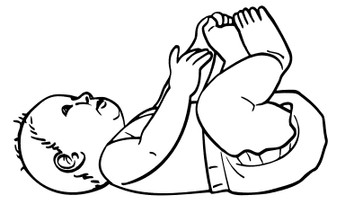
Skills | Baby’s performance
Skills | V | F | N | P
Able to lift his head and chest when lying on his tummy
Able to kick with 1 or both feet when lying on his tummy
Able to roll from his side onto his back
In sitting (with support / being held) his head-control is sufficient
Starts to bring his hands to his midline* (puts it in his mouth / touches blanket or clothes)
Able to kick with his legs while lying on his back

*Midline: The imaginary vertical line that divides the body into 2 parts

Comments:
________________________________________________________________________________________________________________________________________________________________________________________________________________________________________________________________________________________________________________________________________________________________________________________________________________________________________________________________________________________________________________________________________

Communication skills

Skills | Baby’s performance
Skills | V | F | N | P
Reacts verbally to sound
Makes a cooing sound
Looks to see where a sound is coming from
Reacts to loud sounds with the fright reflex*
Calms down when listening to soft music
Turns around when you talk to her
Wakes up when hearing loud sounds / voices
Recognizes some voices and stops crying when she hears it
Smiles in response when someone talks to her
Makes one-letter sounds

*Fright reflex: straightening and then bending arms and legs

Comments:
________________________________________________________________________________________________________________________________________________________________________________________________________________________________________________________________________________________________________________________________________________________________________________________________________________________________________________________________________________________________________________________________________

Cognitive skills
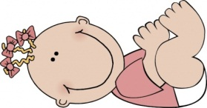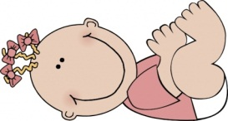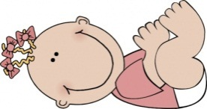
Skills | Baby’s performance
Skills | V | F | N | P
Smiles in response to people / being talked to (selective)
Starts to anticipate objects – e.g. bottle

Comments:
________________________________________________________________________________________________________________________________________________________________________________________________________________________________________________________________________________________________________________________________________________________________________________________________________________________________________________________________________________________________________________________________________

Personality traits / emotional development
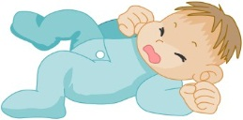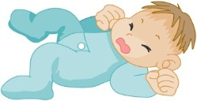
Skills | Baby’s performance
Skills | V | F | N | P
Reacts positively when his needs are met - negatively when he feels uncomfortable
Excited when he sees people
Calms himself by sucking

Comments:
________________________________________________________________________________________________________________________________________________________________________________________________________________________________________________________________________________________________________________________________________________________________________________________________________________________________________________________________________________________________________________________________________

Perception
Visual memory
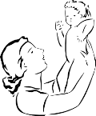

Skills | Baby’s performance
Skills | V | F | N | P
Recognizes her mom / dad

Comments:
________________________________________________________________________________________________________________________________________________________________________________________________________________________________________________________________________________________________________________________________________________________________________________________________________________________________________________________________________________________________________________________________________

Grasp / hand function
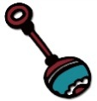
Skills | Baby’s performance
Skills | V | F | N | P
The reaching-action starts to develop
Her hands are open most of the time
Pulls on clothes of other / self
Plays with a rattle

Comments:
________________________________________________________________________________________________________________________________________________________________________________________________________________________________________________________________________________________________________________________________________________________________________________________________________________________________________________________________________________________________________________________________________

Body concept
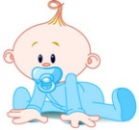
Skills | Baby’s performance
Skills | V | F | N | P
Explores the mouth-area

Comments:
________________________________________________________________________________________________________________________________________________________________________________________________________________________________________________________________________________________________________________________________________________________________________________________________________________________________________________________________________________________________________________________________________

Senses
Vision
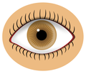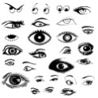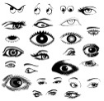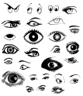
Skills | Baby’s performance
Skills | V | F | N | P
Looks at her own hand movements
Follows a moving person
Follows an object on a string
Makes eye contact
Recognizes her bottle
Recognizes her mom and dad
Accommodation* of eyes are mostly good
Convergence* of eyes are possible
Binocular* vision is possible
Follows a moving object in 180 degrees
Fixates on objects that are close
Follows objects that move vertically
Prefers faces rather than objects

*Accommodation: the ability of the eye to stay focussed as an object it moving nearer/farther away
*Convergence: the simultaneous inward movement of both eyes
*Binocular: when both eyes are used together

Comments:
________________________________________________________________________________________________________________________________________________________________________________________________________________________________________________________________________________________________________________________________________________________________________________________________________________________________________________________________________________________________________________________________________

Hearing
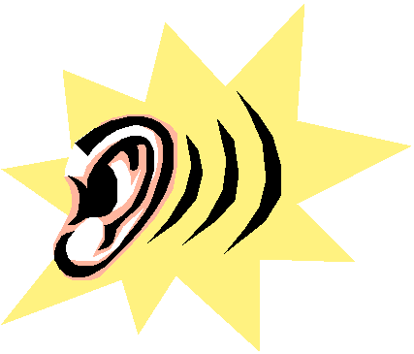
Skills | Baby’s performance
Skills | V | F | N | P
React to noises by turning her head

Comments:
________________________________________________________________________________________________________________________________________________________________________________________________________________________________________________________________________________________________________________________________________________________________________________________________________________________________________________________________________________________________________________________________________

__________________________________ ____________________________________
Signature of Teacher Signature of Principal

The format for this class report was compiled by Carla Grobler – Occupational Therapist and is Copyright protected

